Nepal College of Information Technology
Unit Test
Spring 2012
Program : BE ELX/CE Time : 2 hrs
Semester : (IV) FM : 70
Subject : Electronic Circuits PM : 35

- Candidates are requested to give their answer as far as practicable in their own words.
- The figure in the margin indicates the full marks
- Assume suitable data if necessary
- Attempt ALL question

1 a. Why is Darlington pair amplifier called “Super – Beta Transistor”? 8
b. Derive the input impedance, output impedance and overall gain of Emitter-follower amplifier. 7
2 a. From the figure given below , determine AVs where re = 25Ω , rc = 10KΩ 8
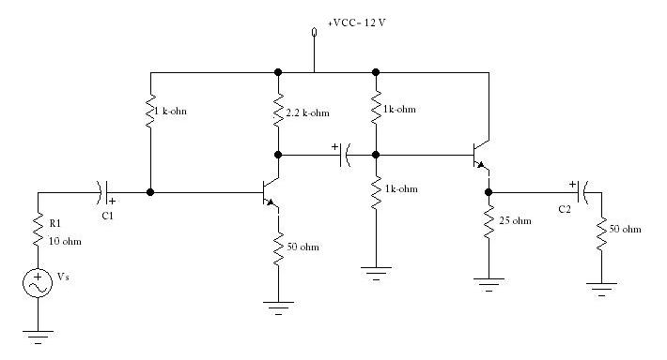

b. What if miller capacitance? Describe the effect of series capacitance on low frequency response of an amplifier. 1+6
3 a. Calculate i/p power , o/p power delicered to transistor ,power lost in transistor , collector efficiency and Conversion efficiency of amplifier shown in figure for an i/p voltage resulting in base current of 10 mA peak. Take β=25 and V_{BE} =0.7V 8
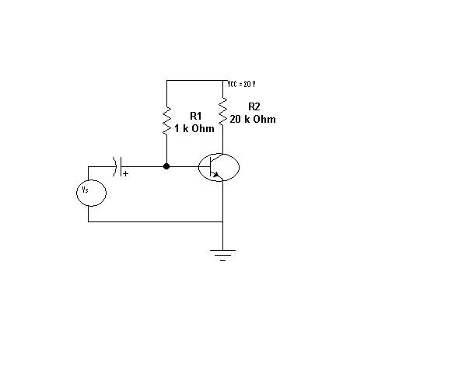
b. “ Negative Feedback Increases Bandwidth and Improves SNR”. Justify this statement. 3 +4
4 a. An amplifier with a gain of 60 dB has an output impedance of 10 KΩ . It is required to modify its output impedance to 1 kΩ.Calculate the feedback factor. Also find the percentage change in overall gain for 10% change in open-loop gain of amplifier. 8
b. Determine the overall efficiency of Direct coupled series –fed Class A amplifier. Why is efficiency less compared to Class B amplifier? 6+1
5. Write short notes on:- (Any two) 5*2 = 10
a. coupling of amplifier
b. Multistage amplifier
c. Choice of transistors in multistage.

